Installing of Jenkins and Launching of A2


First we need to login to our AWS account.
Search for EC2
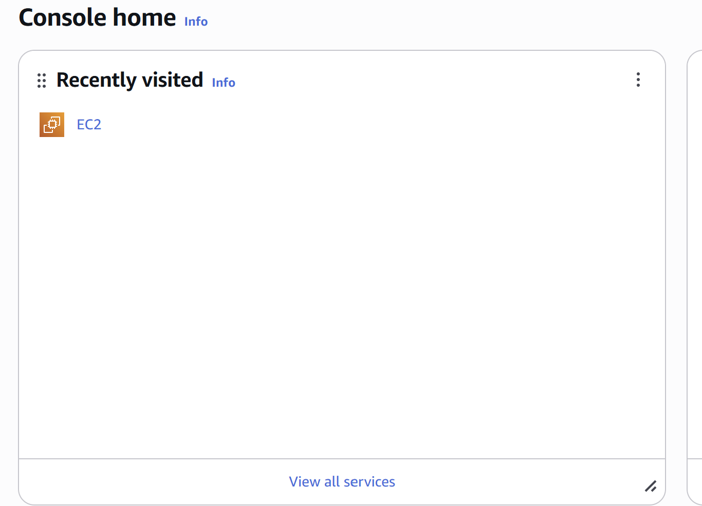
Giving the name
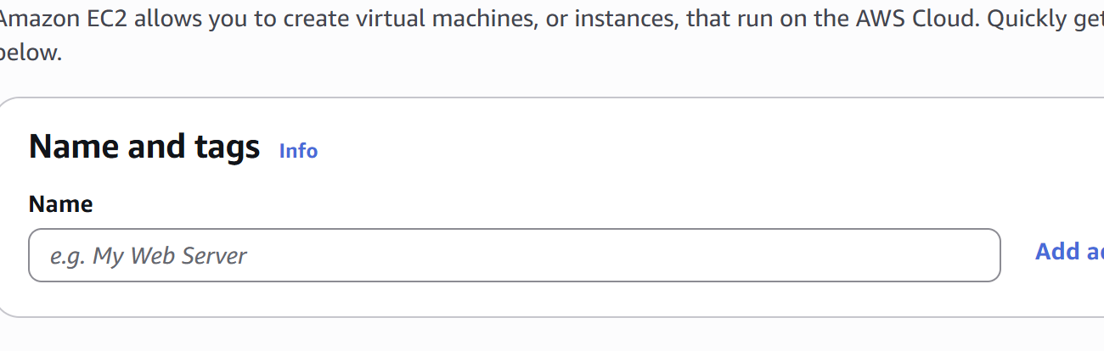
Select machine
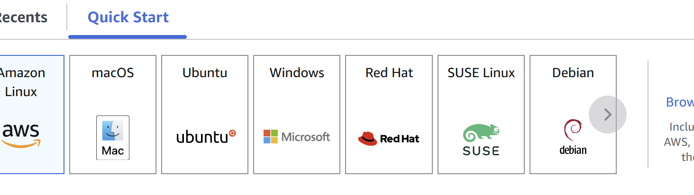
Select architecture and instance type
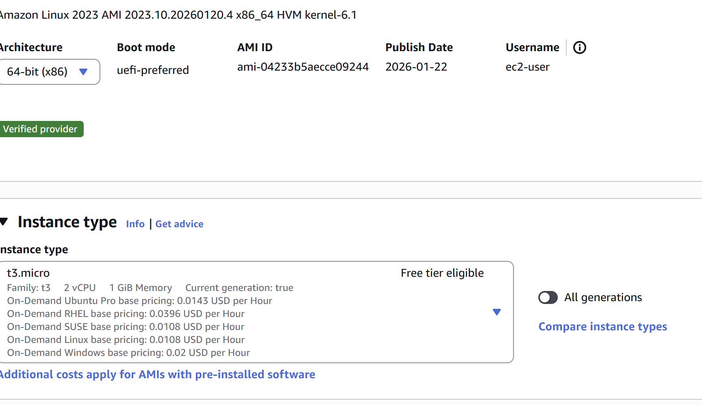
Then name key pair login
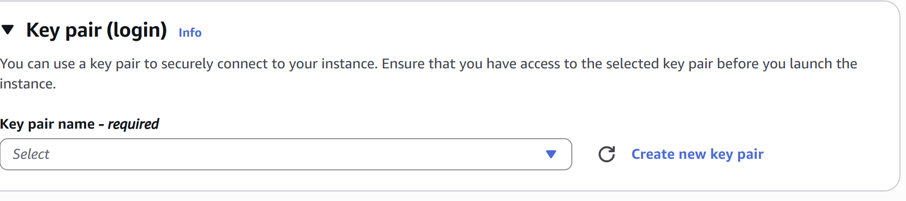
Check all the security groups in fire wall
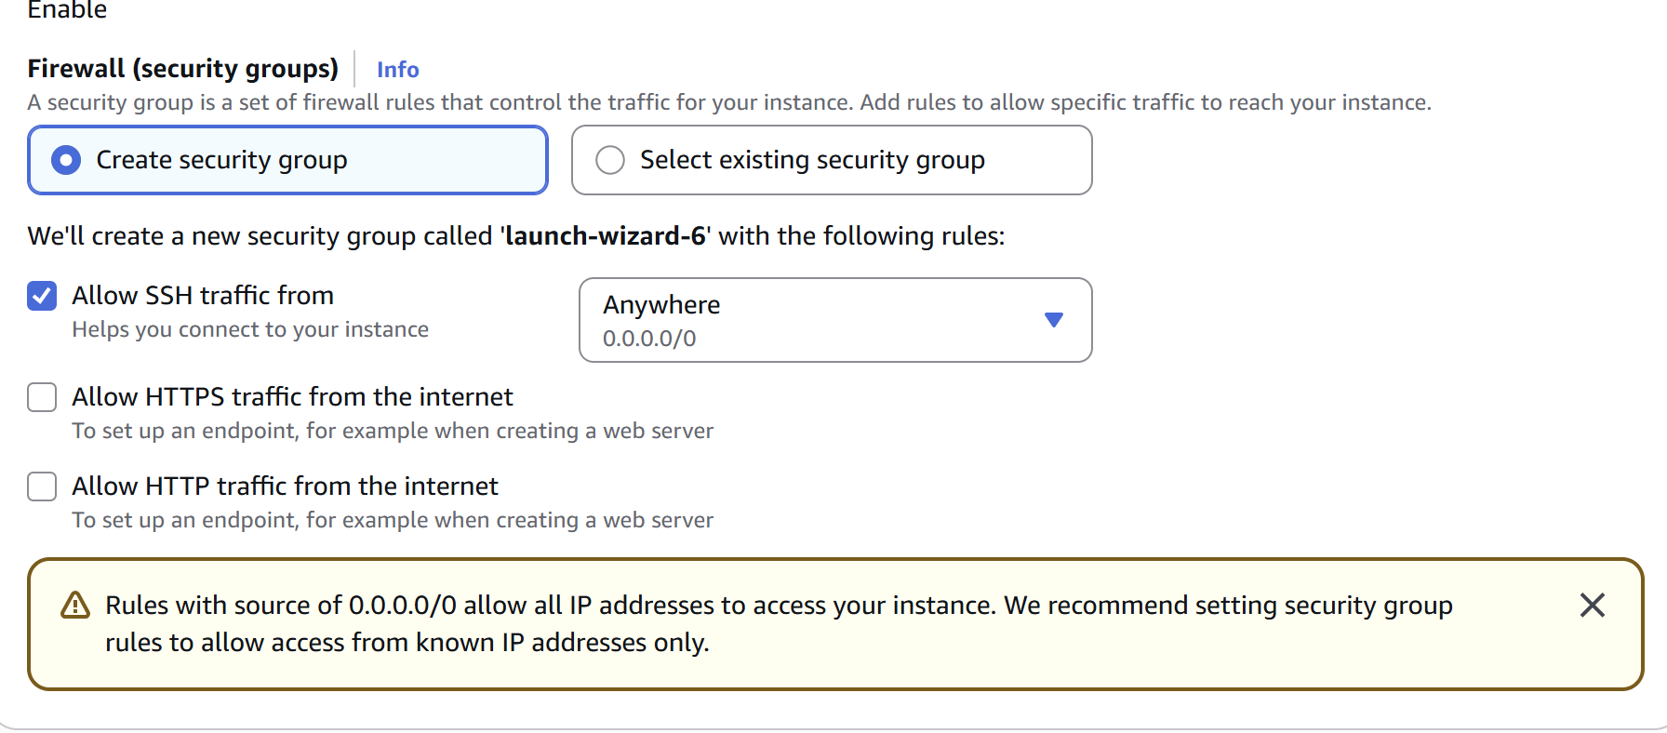
Then select configure storage accordingly
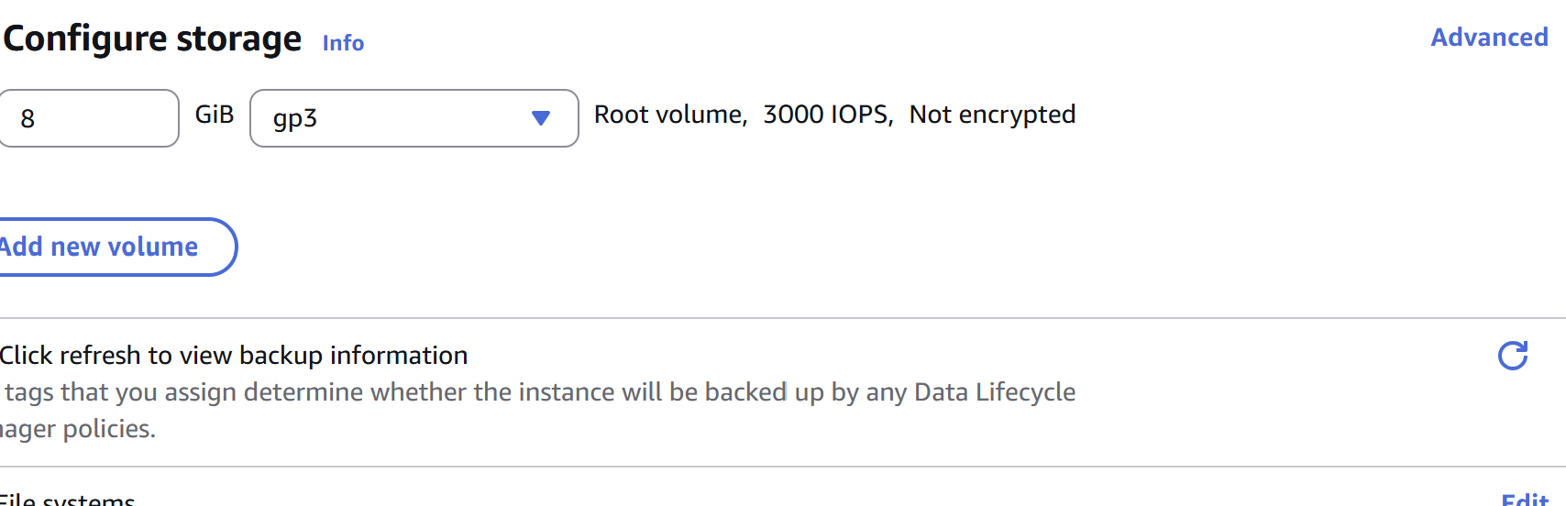
Click on Launch Instance.
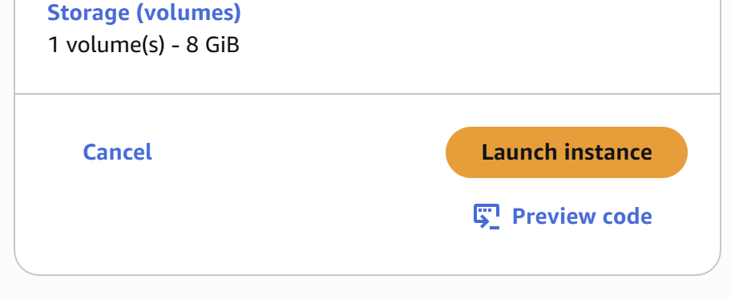
EC2 Successfully launched.
Then click on dashboard > Instances > select instance and click on Connect
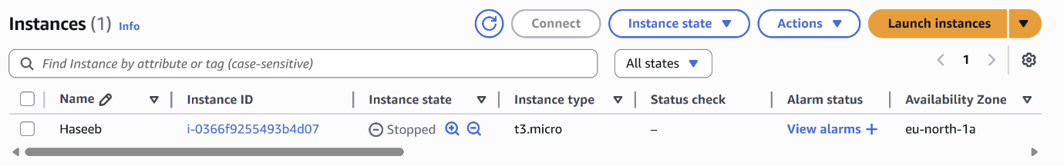
Again click on connect on EC2 instance connect page after naming the username
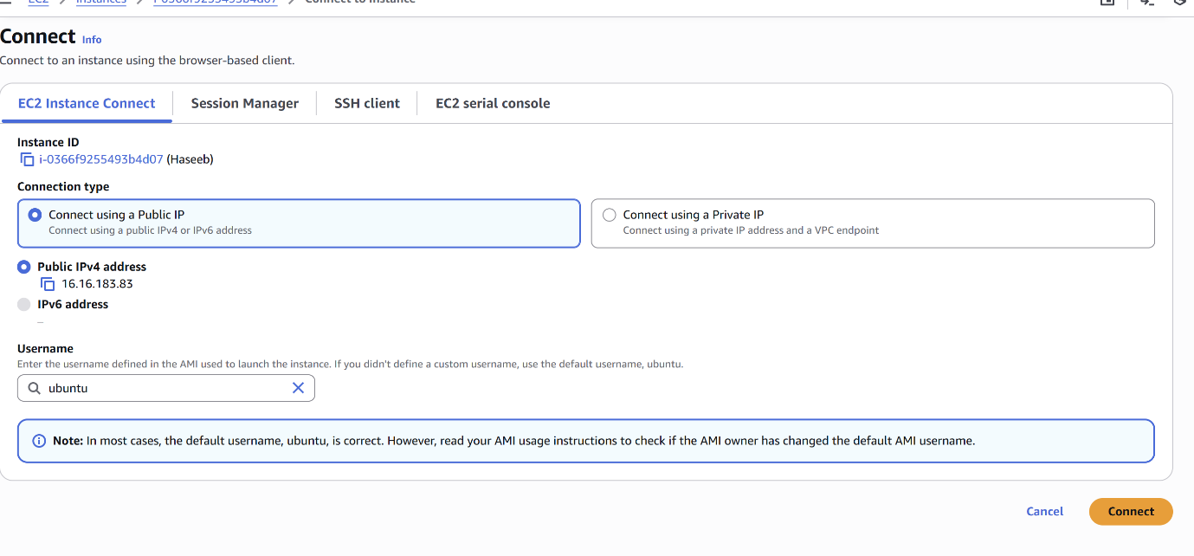
It will open the command page on browser
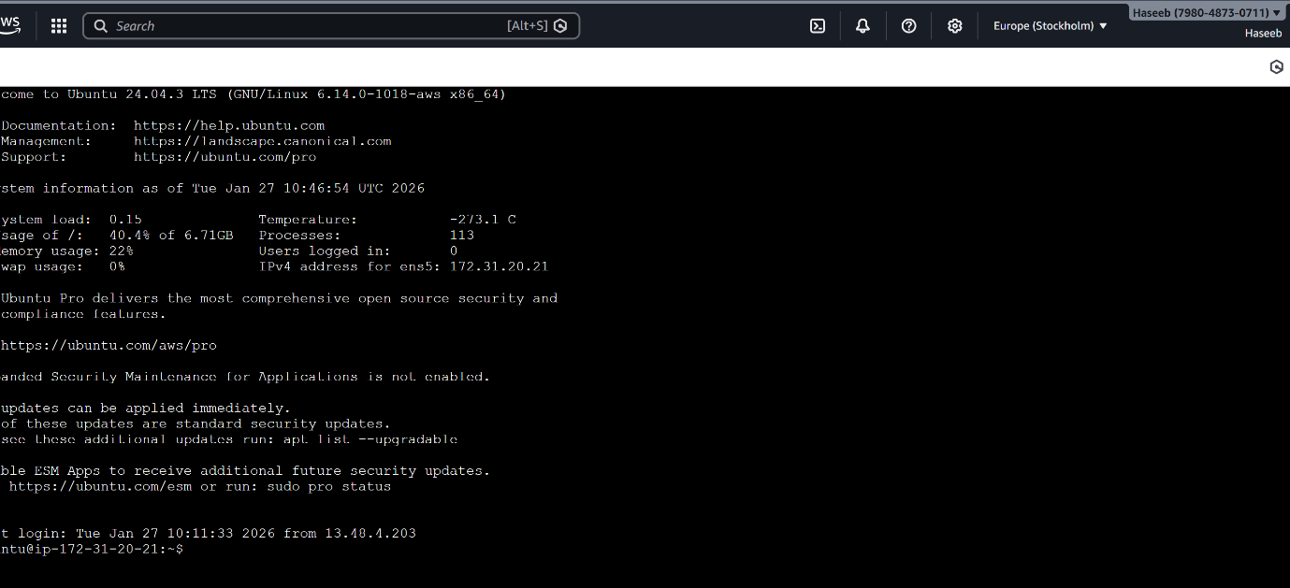
Type sudo apt update {run command}
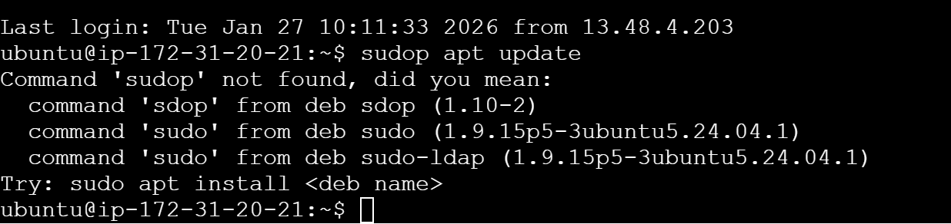
Sudo apt install openjdk-8-jdk to install jenkin
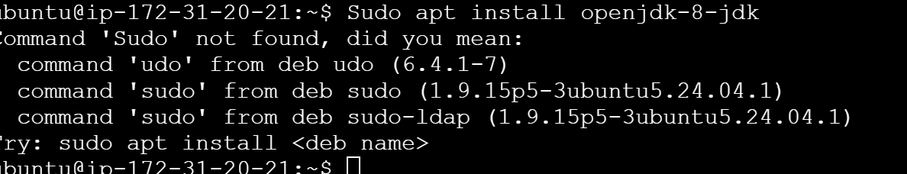
Open the page pkg.jenkins.io

Copy and paste the commands one by one from the Jenkins page
Allow permissions to use extra space on the storage by type Y
To start Jenkins type sudo systemctl start Jenkins
To enable it sudo systemctl enable Jenkins
To check status sudo systemctl status Jenkins
Then you need to so AWS site click on public network which shows Running already
Cope and paste the ipadress
Click on security and edit it adding one rule option by entering 0808 in the place and click on save rule. Then run the page you will able to install it successfully. 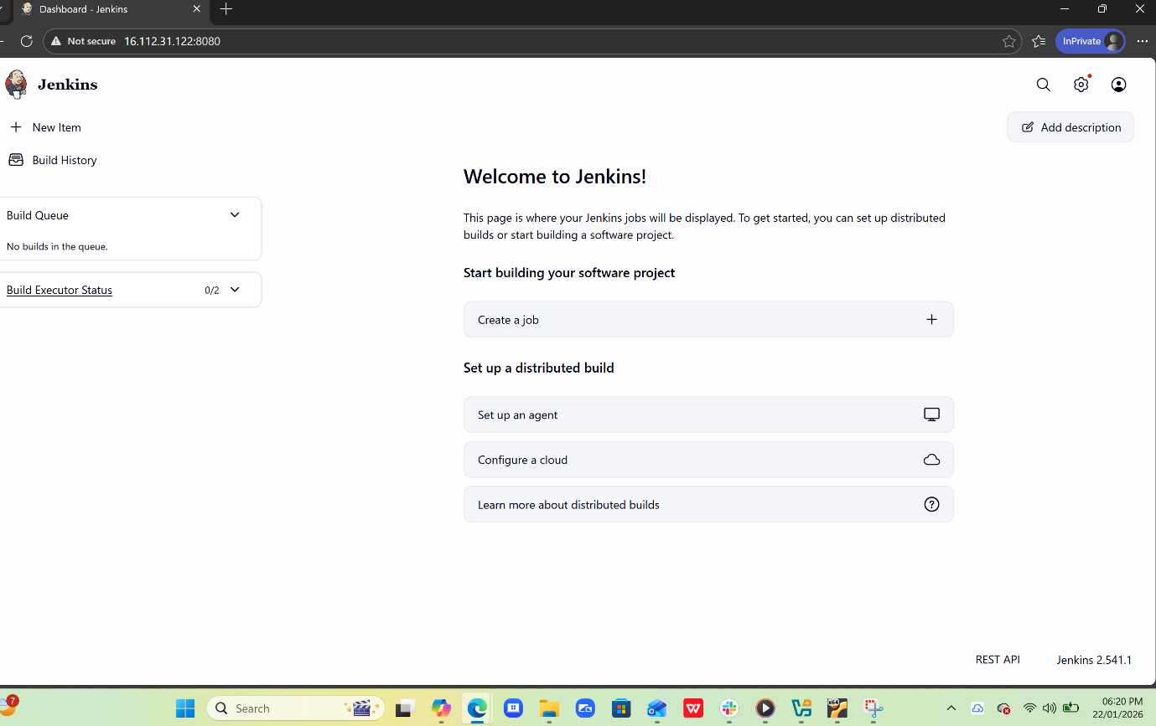

Setup Apache Tomcat on Ubuntu machine.
In order to install tomcat, we need to install java first but before that login to AWS account and connect the instance then follow the steps :-
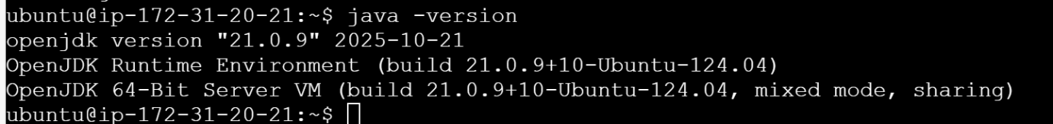
Sudo apt update
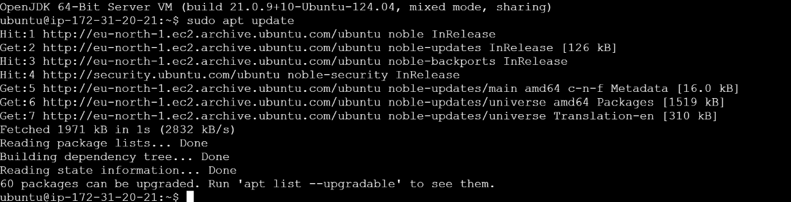
To run java
Sudo apt install default-jdk
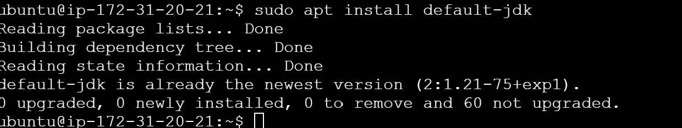
To check if its installed successfully
Java -version
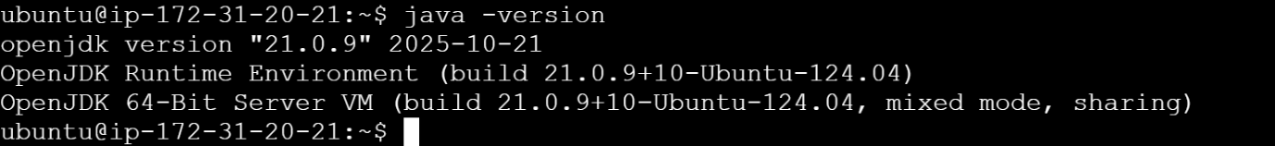
Then search tomcat in google and click on first link, then right click on zip and copy url and then paste it in the page where we working just add “wget” before the link and hit enter.
Check if its in the link by enter “ls”
After copying the zip file now you need to unzip it by entering the command
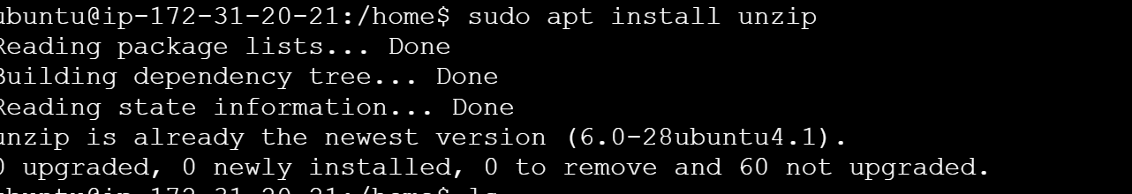
Unzip (paste the url)
Copy in to the bin directory
Cd /opt/tomcat/bin
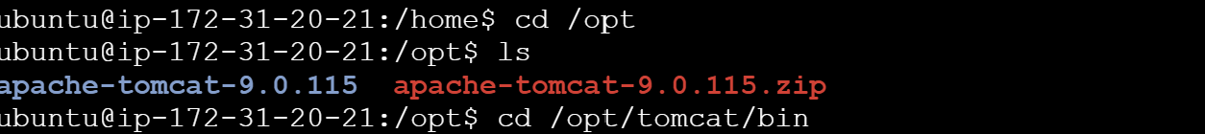
Then give the permissions
sudo chmod +x *.sh
then start the tomcat
./startup.sh
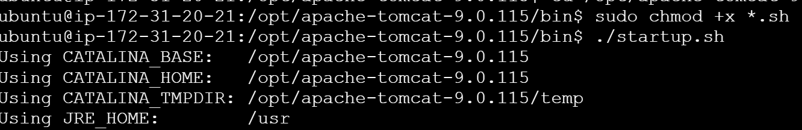
Now open the link in public browser
Localhost:8080
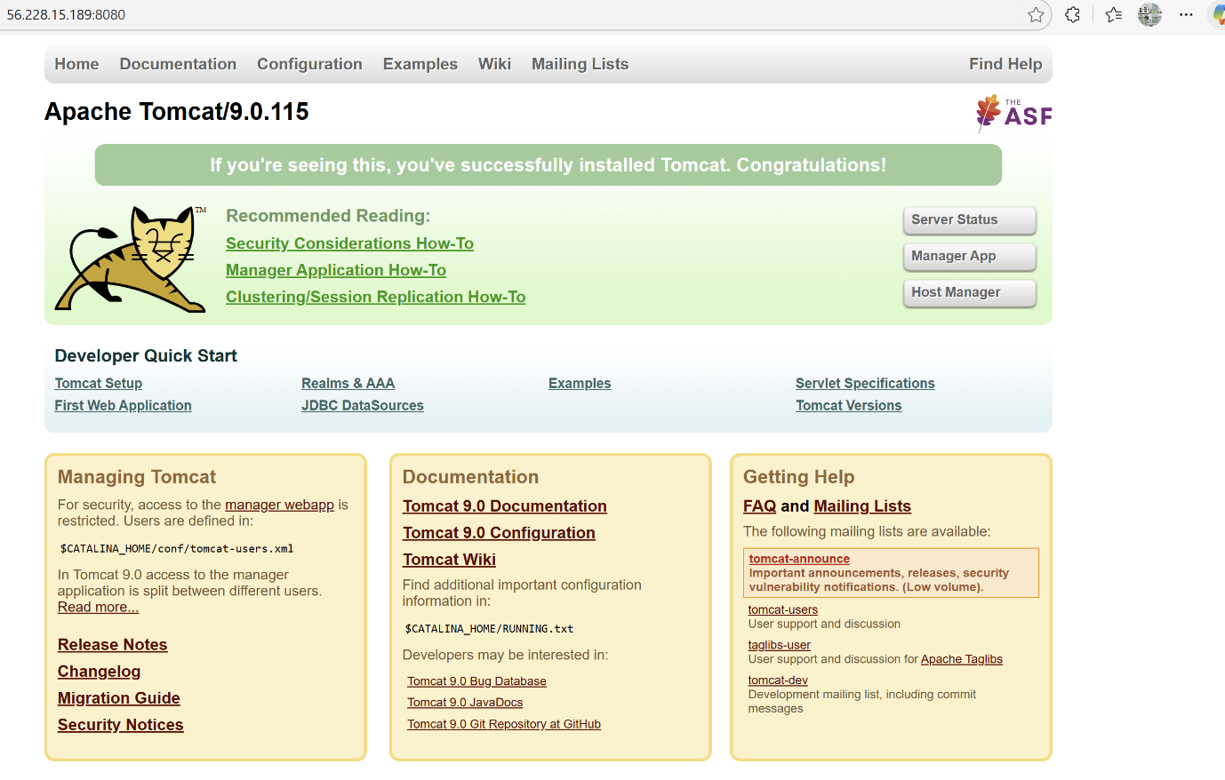
Setup Docker Desktop on your local windows.
Search docker on google
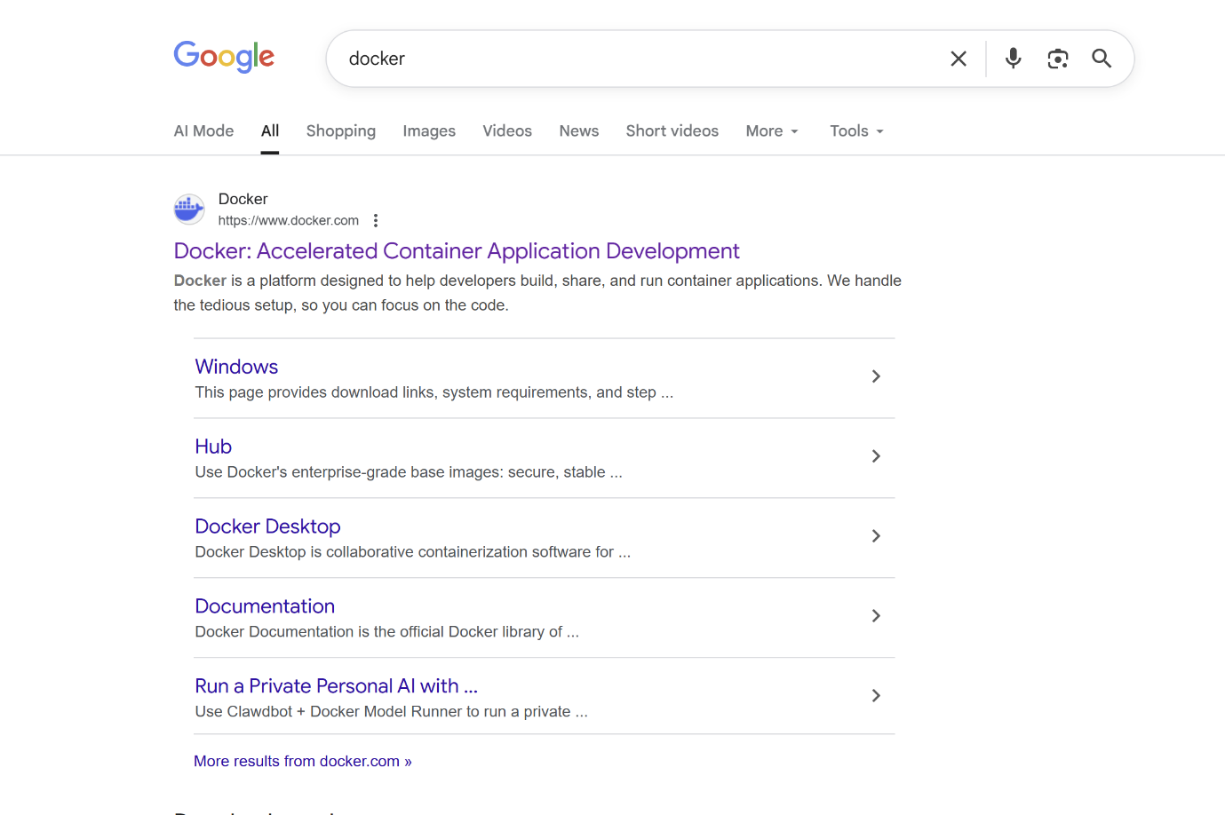
Click on first link and install the docker for windows by clicking on the given option o the page.
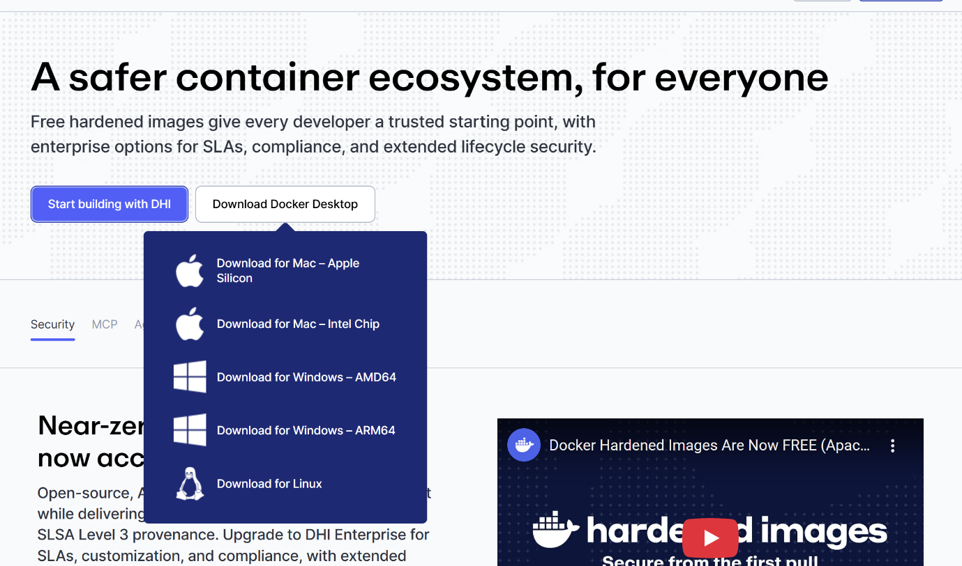
And then it will auto install and restart the machine.
Docker is successfully installed.

